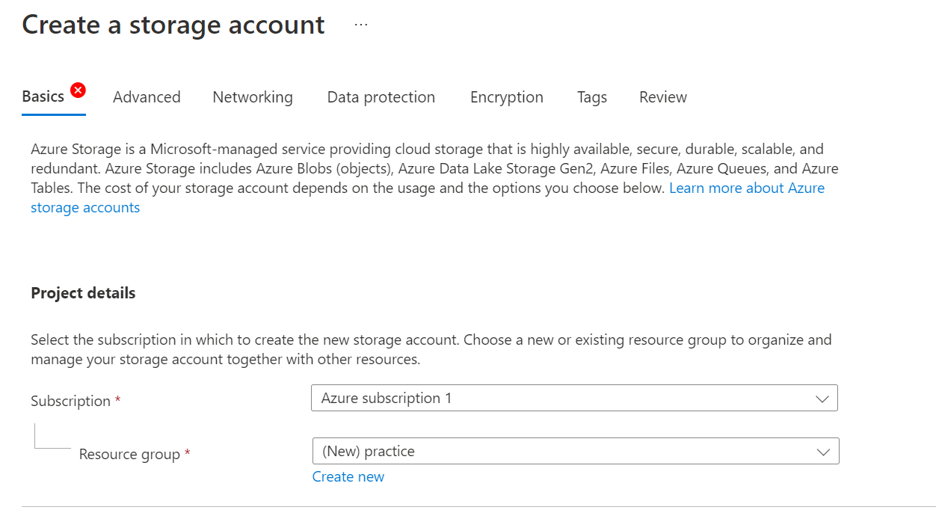

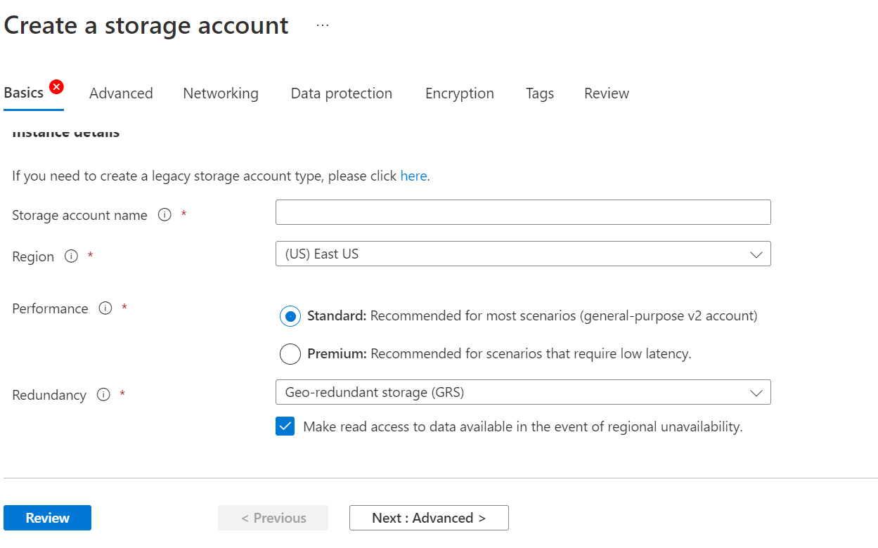

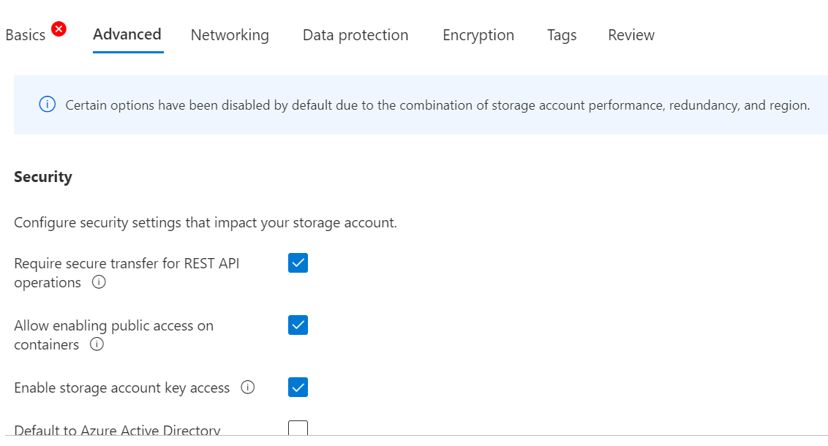

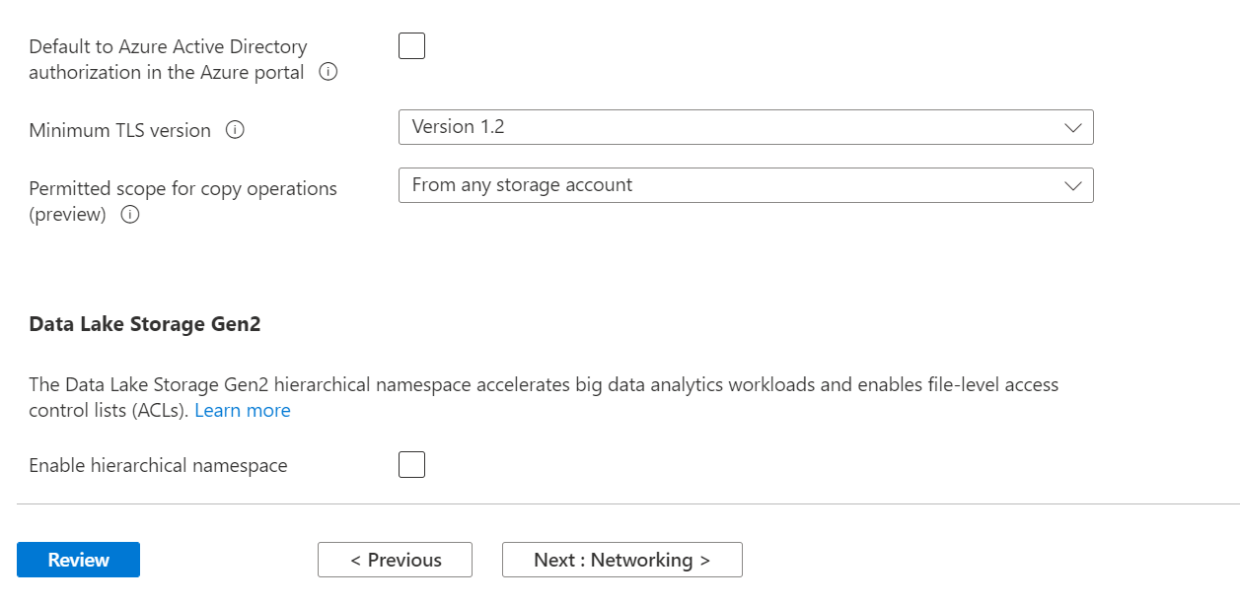

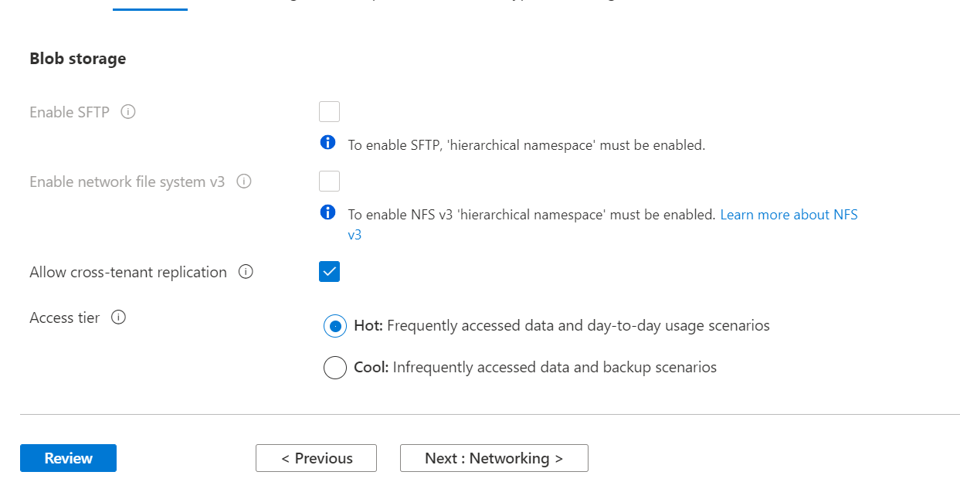

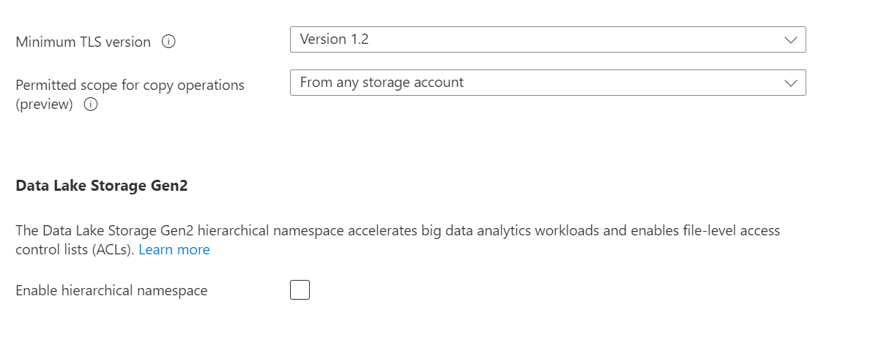

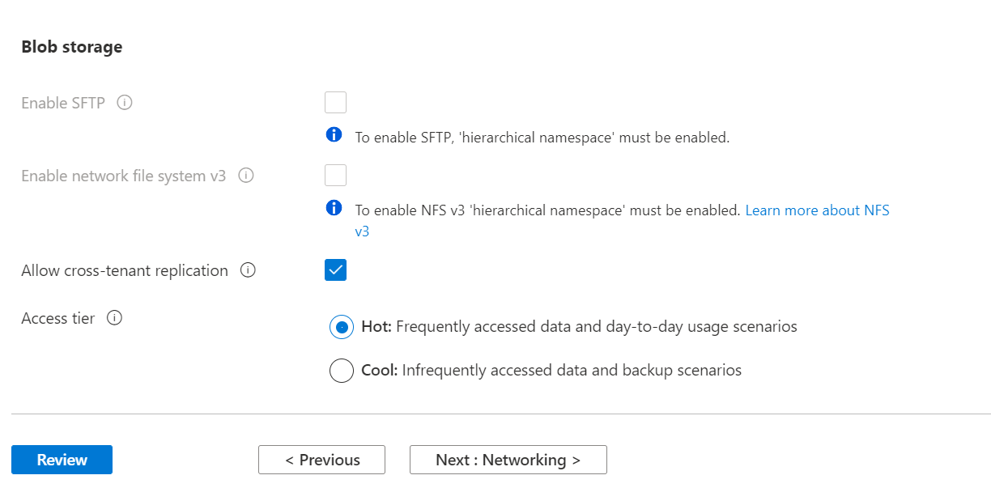

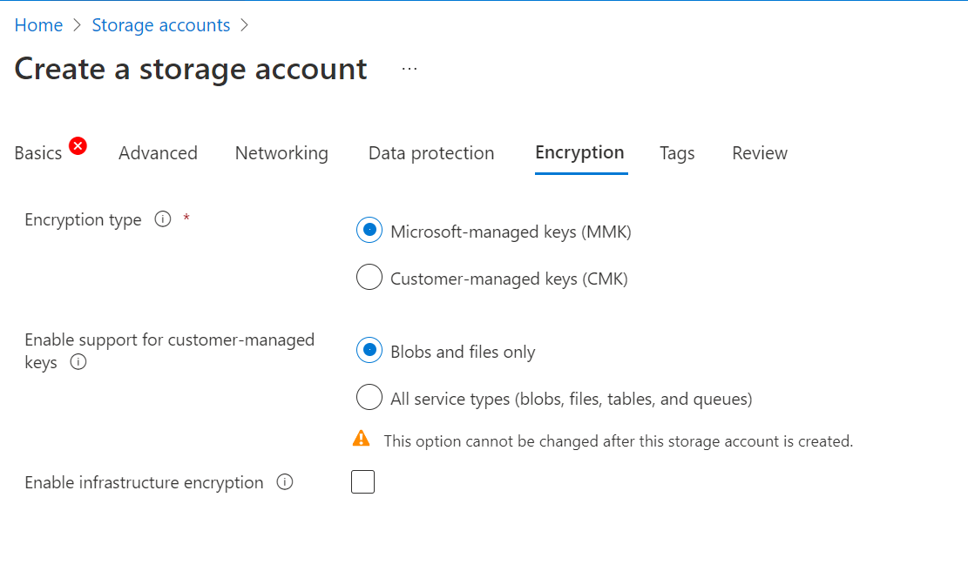

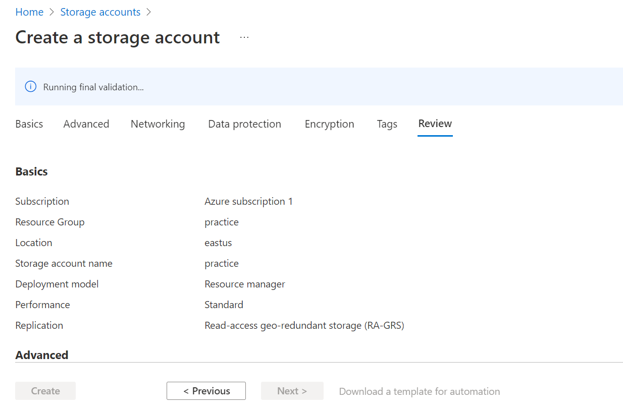

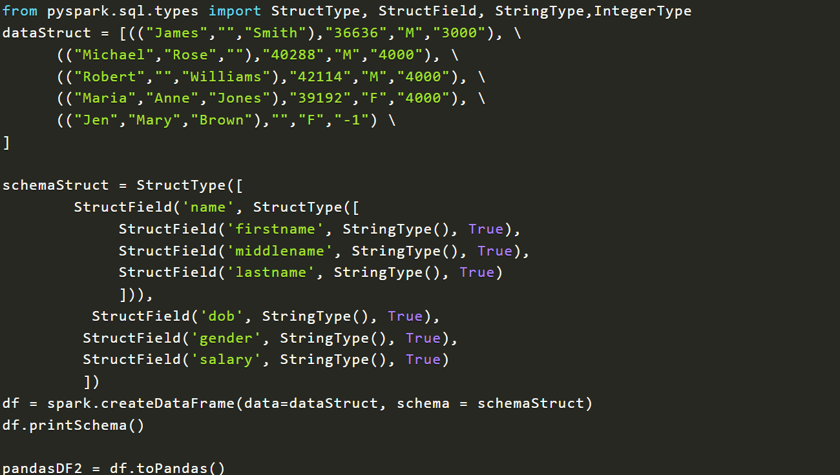

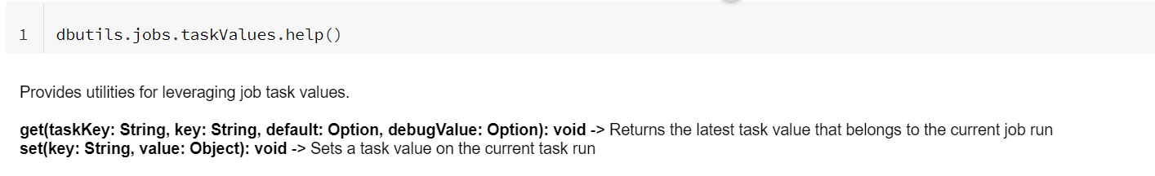

spark.read.format('csv').load('')

spark.write.format('delta').mode('overwrite').option('overwriteSchema','true').save('location')

spark.sql("CREATE TABLE TABLE_NAME USING DELTA LOCATION 'location'")

from pyspark import SparkContext

sc = SparkContext("local", "Spark_example_app")

from pyspark import SparkConf, SparkContext

conf = SparkConf()

conf.setMaster("local").setAppName("Spark example")

sc = SparkContext.getOrCreate(conf)

print(sc.appName)

rdd = spark.sparkContext.range(1,5)

print(rdd.collect())